|  |  |  |  |  |  |  |  |  |  |  |  |  |  |  |  |  |  |
| --- | --- | --- | --- | --- | --- | --- | --- | --- | --- | --- | --- | --- | --- | --- | --- | --- | --- |
| Team Number | | | | | | | | | | | | | | | |  |  |
| 1 | Name of Student: | C | H | I | N | M | A | Y |  | A | V | I | N | A | S | H |  |
| J | A | V | A | L | A | G | I |  |  |  |  |  |  |  |  |
| 2 | Name of Student: | M | E | D | H | A |  | K | M |  |  |  |  |  |  |  |  |
|  |  |  |  |  |  |  |  |  |  |  |  |  |  |  |  |
| 3 | Name of Student: | P | A | V | A | N |  | P | R | A | K | A | S | H |  |  |  |
| M | Y | A | G | E | R | I | M | A | T | H |  |  |  |  |  |
| 4 | Name of Student: |  |  |  |  |  |  |  |  |  |  |  |  |  |  |  |  |
|  |  |  |  |  |  |  |  |  |  |  |  |  |  |  |  |
| 5 | Name of Student: |  |  |  |  |  |  |  |  |  |  |  |  |  |  |  |  |
|  |  |  |  |  |  |  |  |  |  |  |  |  |  |  |  |

|  |  |  |  |  |  |  |  |  |  |  |  |
| --- | --- | --- | --- | --- | --- | --- | --- | --- | --- | --- | --- |
|  | | | | | | | | | | | |
| USN: | | | | | | | | | | | |
| 0 | 1 | F | E | 2 | 0 | B | E | C | 2 | 0 | 0 |
| USN: | | | | | | | | | | | |
| 0 | 1 | F | E | 2 | 0 | B | E | C | 2 | 0 | 1 |
| USN: | | | | | | | | | | | |
| 0 | 1 | F | E | 2 | 0 | B | E | C | 1 | 9 | 9 |
| USN: | | | | | | | | | | | |
|  |  |  |  |  |  |  |  |  |  |  |  |
| USN: | | | | | | | | | | | |
|  |  |  |  |  |  |  |  |  |  |  |  |

Kaggle :Open Challenge / Closed Challenge *(Strikeout the other)*

Project Title:  *Personal AI Gym Trainer*

Problem statement: *To predict what exercise a person is performing. Make use of the angles between the landmarks and help correct the exercise if a person is doing it wrong.*

Summary: *Consider all relevant fields and fill the details*

Type of problem: *Classification*

Type of Machine Learning algorithm: *Supervised*

Number of classes with appropriate labels: *7 - {Lunges, Push-ups, Leg Lifts, Planks, Side Planks, Knee Crunches, Squats}*

Number of features with appropriate labels: *NA*

Model used for classification: *Artificial Neural Network (with softmax as activation for last layer)*

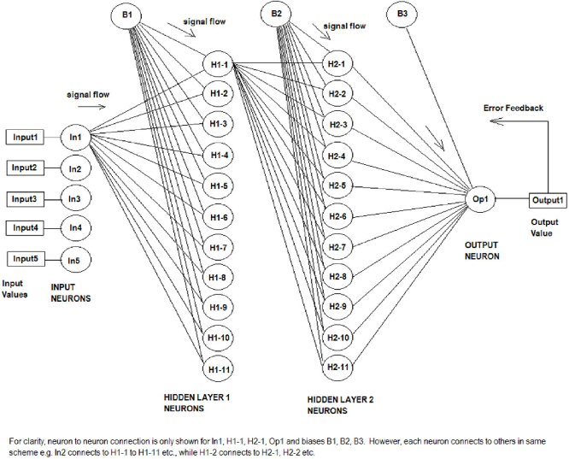

Results and Discussion:

Input Data: *Dataset comprises of the angles at the joints (here, 8 joints, hence 8 angles) which are in columns along with a label of what exercise the angles are.*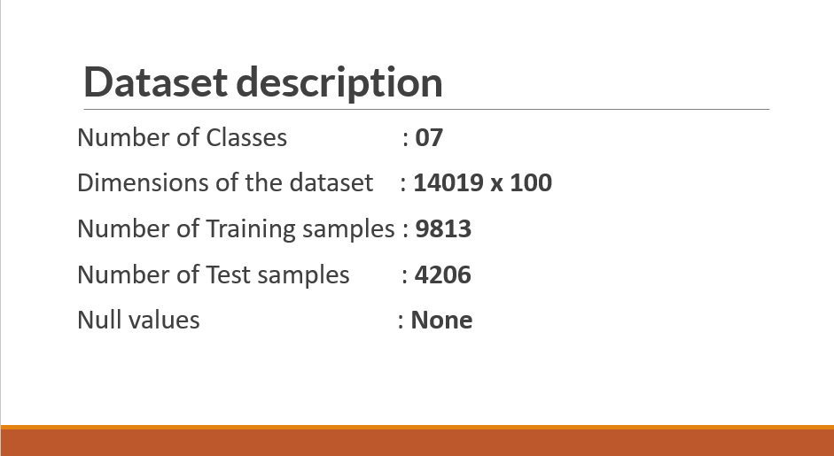

Expected Output: 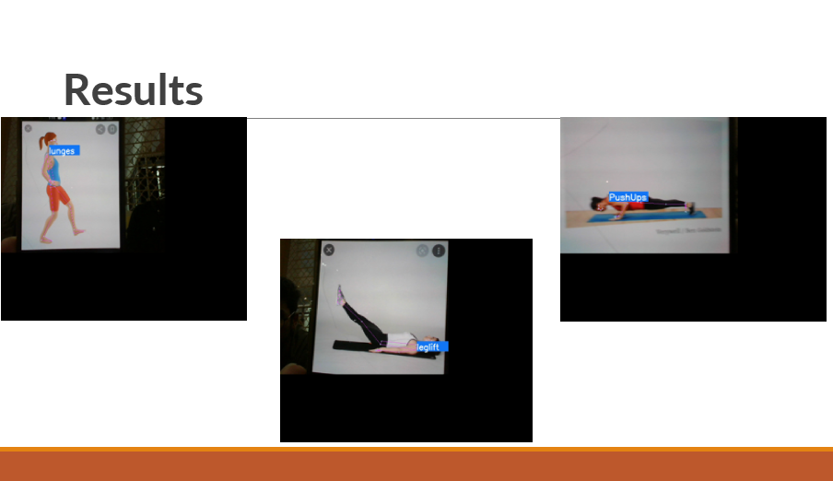

Tools/Programming used: *Python, Tensorflow, Scikit-learn, Mediapipe, OpenCV.*

Accuracy Achieved: *Achieved an accuracy of 99.8% for the test data using –*

* + - *Loss – Categorical CrossEntropy*
    - *Optimizer – Adam with learning rate 0.001*

Confusion matrix (if classification):

*Precision recall f1-score support*

*0 1.00 1.00 1.00 484*

*1 1.00 1.00 1.00 463*

*2 1.00 1.00 1.00 425*

*3 1.00 1.00 1.00 641*

*4 1.00 1.00 1.00 623*

*5 1.00 1.00 1.00 726*

*6 1.00 1.00 1.00 844*

*accuracy 1.00 4206*

*macro avg 1.00 1.00 1.00 4206*

*weighted avg 1.00 1.00 1.00 4206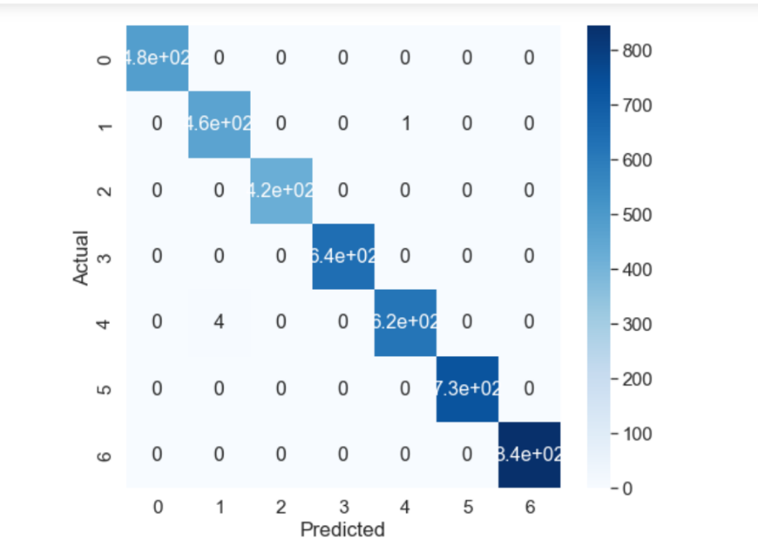*

Visualization of results:

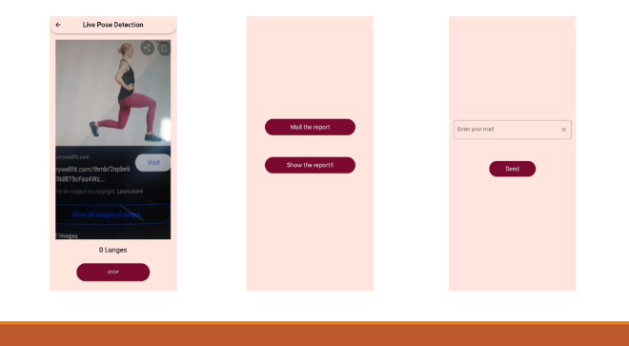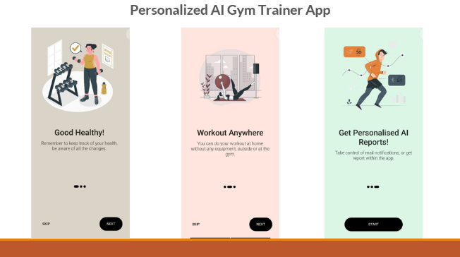

Challenges faced to address the problem:

*Faced difficulty in finding the datasets. Later overcome by using Mediapipe.*

Online Link of the project:

[Link to the Github repository](https://github.com/ChinmayJavalagi/AIGymTrainer)